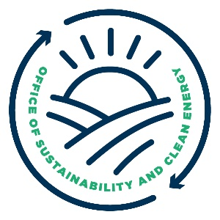
MEETING THE MOMENT
The Wisconsin Climate Action Navigators (WI CAN) Network
hosted by Wisconsin’s Office of Sustainability and Clean Energy (OSCE)
Mon, Oct 6, 2025 @ 11am thru Tues, Oct 7, 2025 @ 3:30pm
UW Stevens Point
DRAFT Agenda Outline

Desired Outcomes
- Create initial draft of WI CAN mission, metrics and strategies
- Lift up progress, identify opportunities, and recognize challenges in climate action
- Deepen connections and facilitate collaboration among Navigators
- New Navigators feel welcomed, connected and informed
- Accelerate climate action work by Navigator organizations

Monday, October 6
11am | Arrival and registration
11:30 to 12:30 | BLOCK ONE: Workshop Options
Noon to 1pm | Lunch
1 to 1:45 | Welcome & introductions
1:45 to 3:15 | BLOCK TWO: Climate action success stories  What’s going well? How can we do more of this?  - Small group & large group activities
3:15 | 15-minute break
3:30 to 5pm | BLOCK THREE: Goals & Metrics  If we are successful, what will be different? How will we know?  - Small group & large group activities
5pm | 90-minute break and hotel check-in
6:30 to 7:30 | Dinner
7:30 to 9pm | BLOCK THREE: Story Walk  In collaboration with Wisconsin Academy of Sciences, Arts & Letters  - Mingle, eat dessert, and participate in opportunities to hear, share, and capture stories of success in climate action

Tuesday, October 7
8am to 9am | Breakfast and participant-led activities
9 to 9:30 | Welcome back
9:30 to Noon | BLOCK FIVE: Next steps for climate action  In the next 1-3 yrs, how can we move these dials in the right direction?  - Small group & large group activities
Noon to 1:30 | BLOCK SIX: Lunch options include guided tour and small group work
1:45 to 2:45 | Next steps report out
2:45 to 3:30 | BLOCK SEVEN: Weaving it all together  - Small group & large group activities
3:30 to 4:30 | Disperse

